### 

### Semester One Examination, 2022

### Question/Answer booklet

# MATHEMATICS METHODS

**UNIT 3**

## Section Two:

## Calculator-assumed

|  |  |
| --- | --- |
| **Your Name:** |  |
| **Your Teacher’s Name:** |  |

## Time allowed for this section

Reading time before commencing work: ten minutes

Working time: one hundred minutes

## Materials required/recommended for this section

***To be provided by the supervisor***

This Question/Answer booklet

Formula sheet (retained from Section One)

***To be provided by the candidate***

Standard items: pens (blue/black preferred), pencils (including coloured), sharpener, correction fluid/tape, eraser, ruler, highlighters

Special items: drawing instruments, templates, notes on two unfolded sheets of A4 paper, and up to three calculators approved for use in this examination

## Important note to candidates

No other items may be taken into the examination room. It is **your** responsibility to ensure that you do not have any unauthorised material. If you have any unauthorised material with you, hand it to the supervisor **before** reading any further.

|  |  |  |  |  |  |
| --- | --- | --- | --- | --- | --- |
| Question | Marks | Max | Question | Marks | Max |
| 7 |  | 8 | 13 |  | 11 |
| 8 |  | 15 | 14 |  | 12 |
| 9 |  | 8 | 15 |  | 10 |
| 10 |  | 8 | 16 |  | 8 |
| 11 |  | 10 |  |  |  |
| 12 |  | 10 |  |  |  |

**Structure of this paper**

|  |  |  |  |  |  |
| --- | --- | --- | --- | --- | --- |
| Section | Number of questions available | Number of questions to be answered | Working time (minutes) | Marks available | Percentage of examination |
| Section One:  Calculator-free | 6 | 6 | 50 | 53 | 35 |
| Section Two:  Calculator-assumed | 10 | 10 | 100 | 100 | 65 |
|  |  |  |  | **Total** | 100 |

**Instructions to candidates**

1. The rules for the conduct of the Western Australian Certificate of Education ATAR course examinations are detailed in the *Year 12 Information Handbook 2019*. Sitting this examination implies that you agree to abide by these rules.
2. Write your answers in this Question/Answer booklet.
3. You must be careful to confine your answers to the specific questions asked and to follow any instructions that are specific to a particular question.
4. Additional pages for the use of planning your answer to a question or continuing your answer to a question have been provided at the end of this Question/Answer booklet. If you use the space to continue an answer, indicate in the original answer space where the answer is continued, i.e. give the page number.
5. **Show all your working clearly.**Your working should be in sufficient detail to allow your answers to be checked readily and for marks to be awarded for reasoning. Incorrect answers given without supporting reasoning cannot be allocated any marks. For any question or part question worth more than two marks, valid working or justification is required to receive full marks. If you repeat any question, ensure that you cancel the answer you do not wish to have marked.
6. It is recommended that you **do not use pencil**, except in diagrams.
7. The Formula sheet is **not** to be handed in with your Question/Answer booklet.

**Section Two: Calculator-assumed (100 Marks)**

This section has **ten** questions. Answer **all** questions. Write your answers in the spaces provided.

Spare pages are included at the end of this booklet. They can be used for planning your responses and/or as additional space if required to continue an answer.

● Planning: If you use the spare pages for planning, indicate this clearly at the top of the page.

● Continuing an answer: If you need to use the space to continue an answer, indicate in the original answer space where the answer is continued, i.e. give the page number. Fill in the number of the question that you are continuing to answer at the top of the page.

Working time: 100 minutes.

**Question 7 (8 marks)**

<EFOFEX>
id:fxd{c2fae747-cec1-4d2d-9d42-265f6304d397}

FXData:
</EFOFEX>

The graphs of the continuous functions and   
are shown at right.

(a) Evaluate the derivative of at . (2 marks)

|  |
| --- |
| Solution |
|  |
| Specific behaviours |
| ✓ Indicates correct application of the product rule  ü Correctly evaluates derivative |

(b) Evaluate the derivative of at . (3 marks)

|  |
| --- |
| Solution |
|  |
| Specific behaviours |
| ü Indicates correct application of chain rule  ü Indicates correct value of  ü Correctly evaluates derivative |

(c) Evaluate the derivative of at . (3 marks)

|  |
| --- |
| Solution |
|  |
| Specific behaviours |
| ü Indicates correct application of quotient rule  ü Indicates correct value of  ü Correctly evaluates derivative |

**Question 8 (15 marks)**

The profit function, in $, of a company producing items, is given by:

1. Interpret the value of in this context. (1 mark)

|  |
| --- |
| Solution |
| is the profit or loss made when zero items are produced. Thus, the company makes a loss of when zero items are produced. |
| Specific Behaviours |
| ü Interprets the value as a **loss of $5500** when zero items are produced |

1. Use Calculus methods to determine the maximum profit. (4 marks)

|  |
| --- |
| Solution |
| and  so, this is a MINIMUM  so, this is a MAXIMUM  The maximum profit is $215 986.93 |
| Specific Behaviours |
| ü Obtains the correct first derivative of  ü Equates to zero and solves for both values of  ü Uses an appropriate Calculus method to determine the nature of both values of  ü Determines the maximum profit |

1. Find the marginal profit when and explain what this value predicts. (3 marks)

|  |
| --- |
| Solution |
| If , then  The profit made on the 51st item produced was $3950. |
| Specific Behaviours |
| ü Substitutes into the correct equation for marginal profit  ü Determines the marginal profit  ü Explains the result indicates the profit of making **one more** item |

1. State the maximum marginal profit and when this occurs. (3 marks)

|  |
| --- |
| Solution |
| Thus the maximum marginal profit is when the 38th item is produced |
| Specific Behaviours |
| ü Equates the correct equation to zero and solves for  ü Determines the marginal profit  ü Explains when it occurs (explain the value of x) |

1. How many items must be produced to ensure a profit? (2 marks)

|  |
| --- |
| Solution |
| CAS Solve: , and  Reject  Between and items, **inclusive**, is needed to ensure a profit is made. |
| Specific Behaviours |
| ü Equates to zero and solve for 3 values of x  ü Reject the negative solution, and gives the correct range of values for x in integers |

1. Determine the average profit when . (2 marks)

|  |
| --- |
| Solution |
| The average profit when is |
| Specific Behaviours |
| ü Divides by to obtain the average profit function  ü Solves for the average profit when |

**Question 9 (8 marks)**

Ryan and Oliver play a game where two normal six-sided dice are rolled, the uppermost number noted and then a third six-sided die is rolled. To win the game the number rolled on the third die must fall between the numbers rolled on the first two dice. For example, if a 2 and a 5 are the rolled on the first two dice, to win the game a 3 or a 4 must be rolled on the third dice.

1. Determine the probability that a player has no chance of winning before even rolling the third die.

(HINT: Showing the sample space is helpful) (3 marks)

|  |
| --- |
| Solution |
| If the first two dice are rolled, and their numbers are noted, the table below shows the number of values that sit between the noted numbers from each die:   |  |  |  |  |  |  |  | | --- | --- | --- | --- | --- | --- | --- | |  | **1** | **2** | **3** | **4** | **5** | **6** | | **1** | 0 | 0 | 1 | 2 | 3 | 4 | | **2** | 0 | 0 | 0 | 1 | 2 | 3 | | **3** | 1 | 0 | 0 | 0 | 1 | 2 | | **4** | 2 | 1 | 0 | 0 | 0 | 1 | | **5** | 3 | 2 | 1 | 0 | 0 | 0 | | **6** | 4 | 3 | 2 | 1 | 0 | 0 |   The probability that a player has no chance of winning before the third die is rolled is |
| Specific Behaviours |
| üü Shows the sample space for the first two dice rolled (-1 for each error)  ü Determines the probability |

1. Let the random variable, , be the number of numbers between the first two dice. Complete the probability distribution table below. (2 marks)

|  |  |  |  |  |  |
| --- | --- | --- | --- | --- | --- |
|  | 0 | 1 | **2** | **3** | **4** |
|  |  |  |  |  |  |

|  |
| --- |
| **Specific Behaviours** |
| üü Correct probabilities (-1 for each error) |

1. Determine the probability that a player wins the game. (3 marks)

|  |
| --- |
| **Solution** |
|  |
| **Specific Behaviours** |
| ü Multiplies each score by its probability  ü Multiplies by 1/6  ü Determines the probability |

Question 10 (8 marks)

The mining town of Clipalmerton has been experiencing population exponential growth over the last decade.

(i.e.  where  is the population at years)

The population of the town 10 years ago was 10 000, and there are now (at the beginning of 2022) an extra 1600 people living in the town.

1. Assuming the growth rate of the population remains the same in the future, use this information to write an equation to predict the population of Clipalmerton years from the beginning of 2022.

(3 marks)

|  |
| --- |
| **Solution** |
| The model for is |
| **Specific Behaviours** |
| ü Finds the population for 2022  ü Solves for the value of  ü Shows the correct model for from the year 2022  *Note: Accept* |

1. Hence predict the population of Clipalmerton at the beginning of 2030. (1 mark)

|  |
| --- |
| **Solution** |
| people |
| **Specific Behaviours** |
| ü Solves for the number of people at the beginning of 2030  *Note: Accept 13063 people and 13058 people (followed through )* |

1. The nearby town of Scomotown has also been growing, but its population growth has been such that the equation to predict its population in years’ time (from the beginning of 2022) is:
2. What is the current population of Scomotown (at the beginning of 2022)? (1 mark)

|  |
| --- |
| **Solution** |
| The current population is 10000 |
| **Specific Behaviours** |
| ü Substitutes and solves for the current population |

1. During which years will the population of Scomotown be greater than the population of Clipalmerton? (3 marks)

|  |
| --- |
| **Solution** |
| is where the population of Scomotown will be greater than the population of Clipalmerton. Thus this occurs between the years **2032 to 2065** |
| **Specific Behaviours** |
| ü Solves for 1 value of  ü Solves for both values  ü States between which years Scomotown will have a greater population than Clipalmerton  *Note: Accept beginning in 2031 and/or ending in 2064* |

Question 11 (10 marks)

(a) Given the variance of a Bernoulli distribution is 0.2176, determine the mean. (2 marks)

|  |
| --- |
| **Solution** |
|  |
| **Specific Behaviours** |
| ü Sets up the equation for variance  ü States both values of p are possible means |

(b) The probability of success of a Bernoulli trial is p. Given that it is repeated n times, the expected value and variance of the resulting distribution of the number of successes are 7.52 and 3.9856 respectively. Determine n and p. (4 marks)

|  |
| --- |
| **Solution** |
|  |
| **Specific Behaviours** |
| ü Identifies distribution of successes as binomial  ü States equation for mean  ü States equation for variance  ü Solves equations for n and p |

(c) The probability of Jeremy being late to his Maths class is 0.3, and the probability that he is late to his

Maths class on any day is independent of whether he was late on the previous day.

Over five consecutive weekdays, what is the probability that Jeremy

(i) is only late to his Maths class on Tuesday? (1 mark)

|  |
| --- |
| **Solution** |
|  |
| **Specific behaviours** |
| ✓ correct probability |

(ii) is late on Tuesday and on at least two other days? (3 marks)

|  |
| --- |
| **Solution** |
|  |
| **Specific behaviours** |
| ✓ identifies binomial situation for other two days  ✓ evaluates probability of being late on two other days  ✓ determines probability  *Note: Max 1 mark f.t.for binomial CDf(2, 5, 5, 0.3)=0.16308* |

Question 12 (10 marks)

A square based prism as shown in the diagram has a hemisphere added to its top in such a way that the diameter of the hemisphere is the same as the width of the box. The volume () of the object is 800 cm3.

*x*

*x*

*y*

(a) Determine in terms of and . (1 mark)

|  |
| --- |
| **Solution** |
|  |
| **Specific Behaviours** |
| * Correct answer |

(b) Show that the value of y is given by (2 marks)

|  |
| --- |
| **Solution** |
|  |
| **Specific Behaviours** |
| * Substitutes the volume as 800 * Shows rearranging and simplifies to get |

(c) Show that the surface area of the shape, , is given by (3 marks)

|  |
| --- |
| **Solution** |
|  |
| **Specific Behaviours** |
| * Correct formula for surface area in terms of and * Substitutes from part b) * Simplifies to obtain the correct equation for |

(d) Using calculus to justify your answer, determine the minimum possible surface area of the prism and the value of for which it occurs. (4 marks)

|  |
| --- |
| **Solution** |
| Using CAS Solve:  (+ve, so we have a minimum)  cm2  Thus the minimum surface area is cm2 ­at cm |
| **Other Solutions** |
|  |
| **Specific Behaviours** |
| * Correctly determines * Equates to zero and solves for * Uses the sign test or second derivative test to justify is a minimum * Clearly states the value of and the minimum surface area |

Question 13 (11 marks)

Consider the graph below

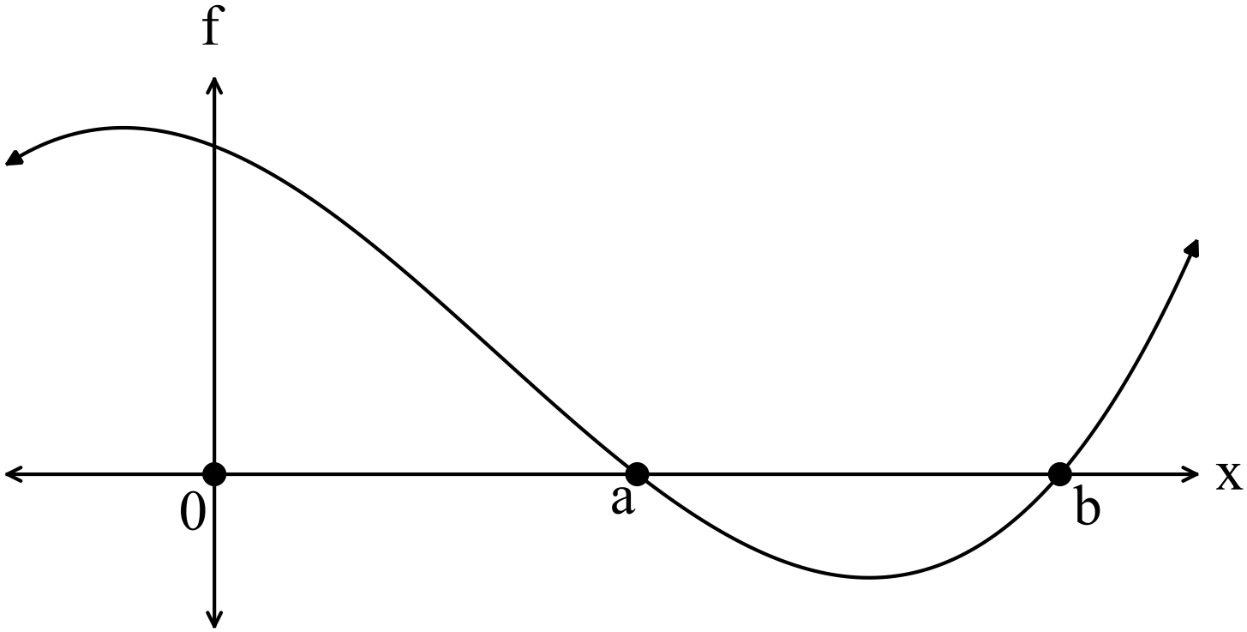

1. Given and
2. Evaluate  (2 marks)

|  |
| --- |
| **Solution** |
|  |
| **Specific Behaviours** |
| * Uses linearity to evaluate the integral * Correctly evaluates the integral |

1. Determine the area bounded by the function, the - axis and – axis on the interval 

(2 marks)

|  |
| --- |
| **Solution** |
|  |
| **Specific Behaviours** |
| * Recognises that the region from to needs to be positive * Determines the correct area |

The function  is graphed below.

b)

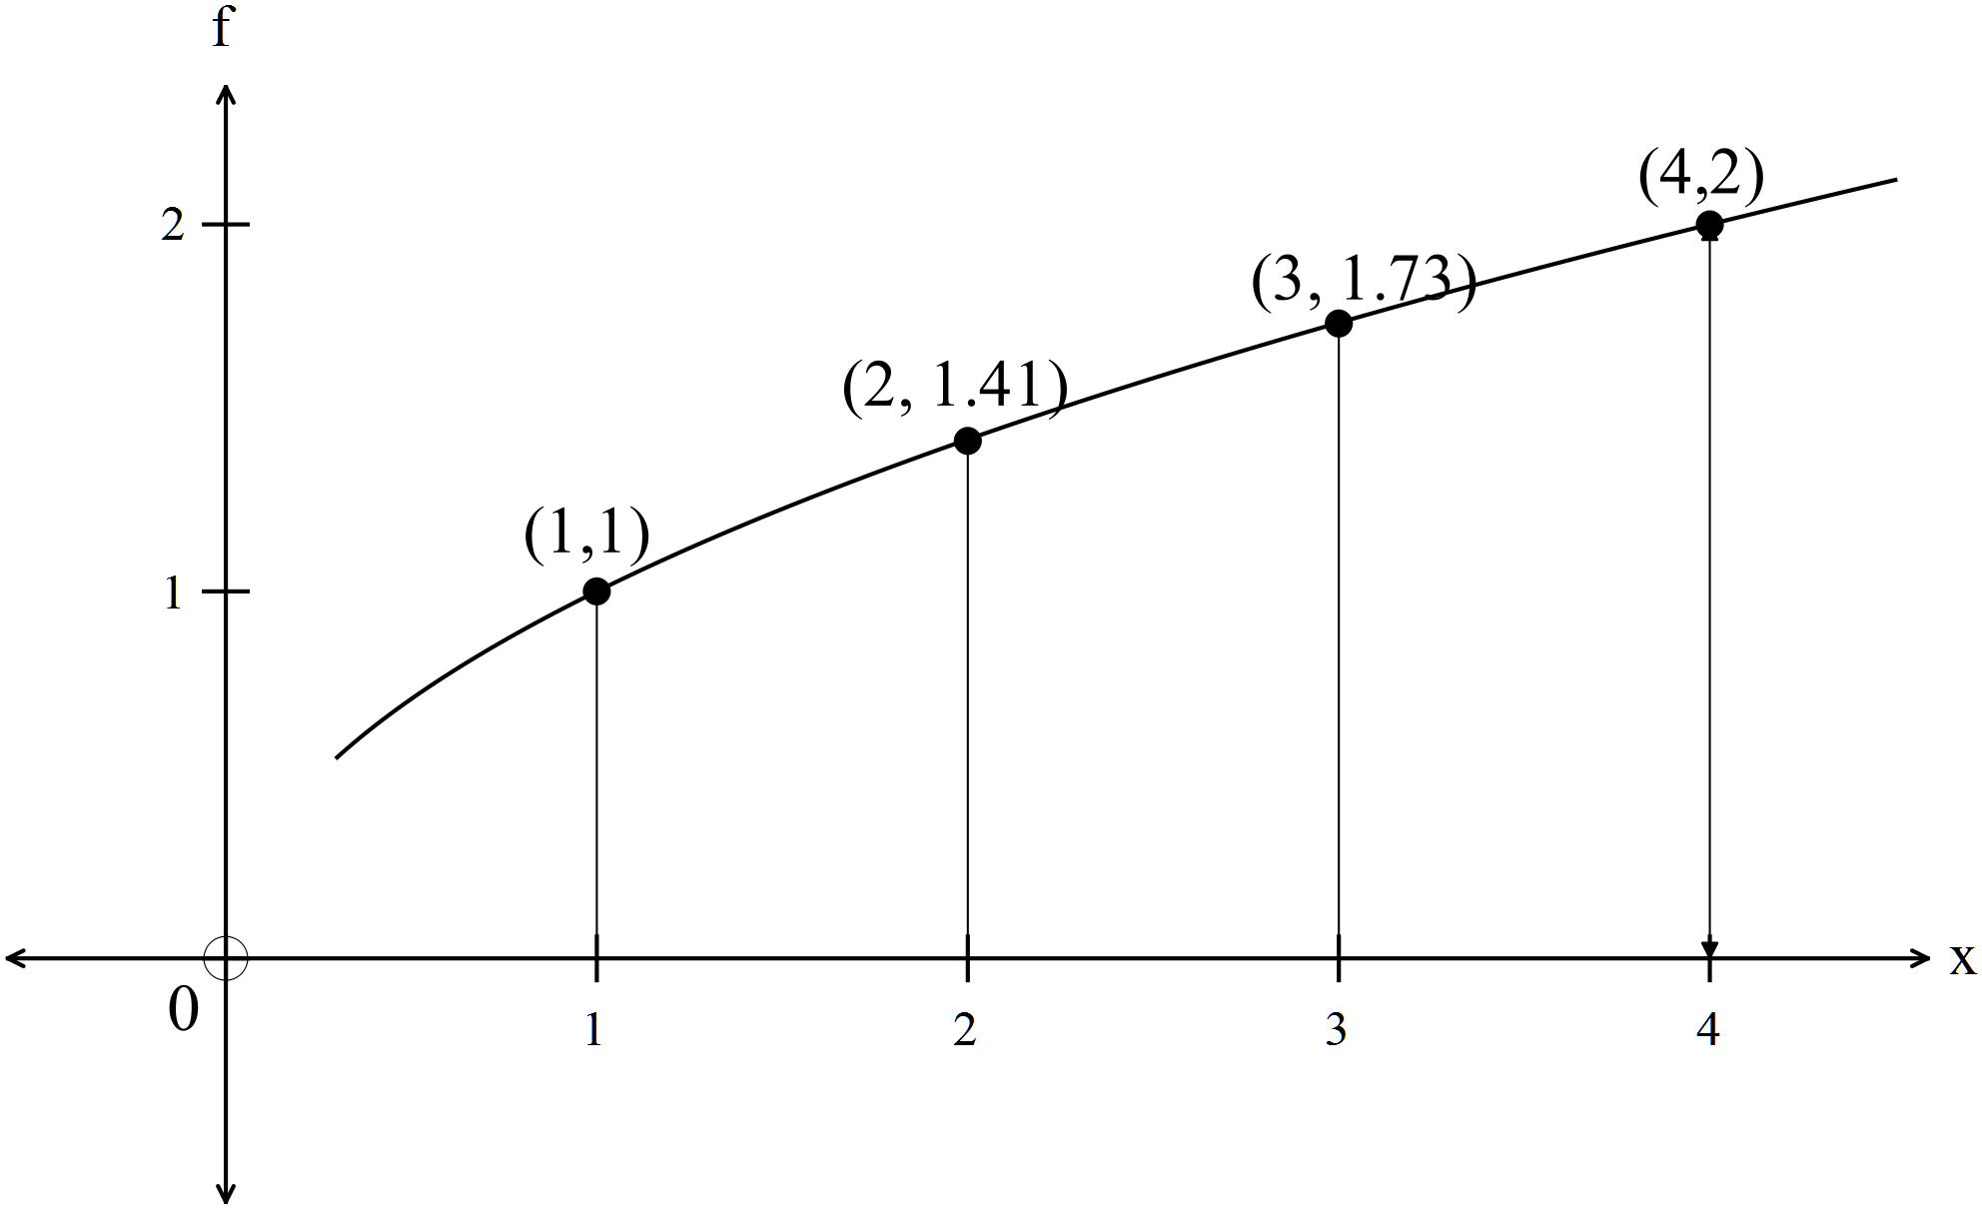

1. Using rectangles from above and from below, find an estimate for the area between the function, and theaxis. Use as the width of the interval.

(5 marks)

|  |
| --- |
| **Solution** |
| From below:    From above:    The average of the two estimates is 4.64 |
| **Specific Behaviours** |
| * Shows the calculation for the underestimation * Determines the correct underestimation * Shows the calculation for the overestimation * Determines the correct overestimation * Determines the average of the two estimations |

(ii) Use integration to evaluate the exact area estimated in (i). (2 marks)

|  |
| --- |
| **Solution** |
| units2 |
| **Specific Behaviours** |
| * Sets up an appropriate integral to calculate the area * Determines the correct area (Must be exact) |

Question 14 (12 marks)

Dezz installs outdoor security lights that are connected to a system which has been configured so that all the lights will turn on if their sensors detect motion. The system will continue to work if at least three of the lights are working. There is a 6% chance that any light fails. If the random variable is the number of lights that fail,

1. State the distribution of , including its parameters, and state two assumptions that were required to use this distribution. (4 marks)

|  |
| --- |
| Solution |
| We can assume a binomial distribution if:   * The probability of any light failing is independent. * The probability of a light failing is constant for successive trials of the same experiment. |
| Specific Behaviours |
| ü States a binomial distribution  ü States the parameters of the distribution  ü Gives one appropriate reason for the use of the distribution  ü Gives two appropriate reasons for the use of the distribution |

1. If the variance of is ,
   1. Determine the number of lights that have been used. (2 marks)

|  |
| --- |
| Solution |
|  |
| Specific Behaviours |
| ü Substitutes values into the formula for variance  ü Determines the correct value of |

* 1. What is the probability that less than half the lights fail given more than 1 light failed? (2 marks)

|  |
| --- |
| Solution |
|  |
| Specific Behaviours |
| ü Shows the correct numerator  ü Calculates the probability |

* 1. What is the probability that the system fails? (2 marks)

|  |
| --- |
| Solution |
| The system will fail if 4 or more lights fail (as the system continues to work if at least three lights are working). Thus, the probability that the system fails is: |
| Specific Behaviours |
| ü Shows the correct numerator  ü Calculates the probability |

1. One night, Dezz removes two of the lights so that they can be repaired. The lights are not replaced for the next night. What is the probability that the system works for that night?

(2 marks)

|  |
| --- |
| Solution |
| For the system to continue working, at most two lights can fail.  Let  (this is the probability that the system fails)  Thus the probability that the system works for that night is 0.9801. |
| Specific Behaviours |
| ü States the distribution of the new random variable with correct parameters  ü Calculates the probability |

Question 15 (10 marks)

The displacement in metres, 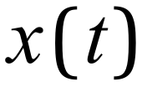, of a particle t seconds after it was launched is given by:

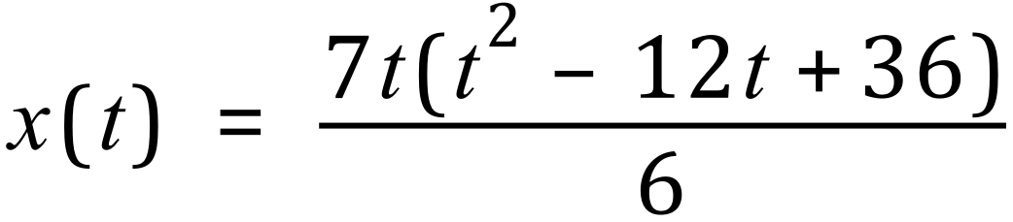 , 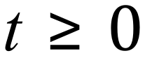 .

(a) Determine the velocity function, , for the particle. (2 marks)

|  |
| --- |
| **Solution** |
|  |
| **Specific behaviours** |
| ü relates velocity to first derivative of displacement wrt t  ü determines the first derivative |

(b) Determine the displacement of the particle at the instant it is stationary. (3 marks)

|  |
| --- |
| **Solution** |
|  |
| **Specific behaviours** |
| ü solves v=0 for two values  üdetermines displacement for one value  ü both values |

(c) Determine the acceleration function, 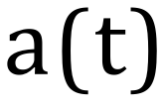 , for the particle. (2 marks)

|  |
| --- |
| **Solution** |
|  |
| **Specific behaviours** |
| ü relates acceleration to first derivative of velocity wrt t  ü determines acceleration function |

(d) How far has the particle travelled before its acceleration is zero? (3 marks)

|  |
| --- |
| **Solution** |
| 56 metres |
| **Specific behaviours** |
| ü equates acceleration to 0 and determines t  ü shows integration expression for distance travelled  ü determines how far the particle has travelled |

**Question 16 (8 marks)**

A sculpture has a cross-section shown below (indicated by the shaded region). All measurements are in metres. The equation of the curve is for

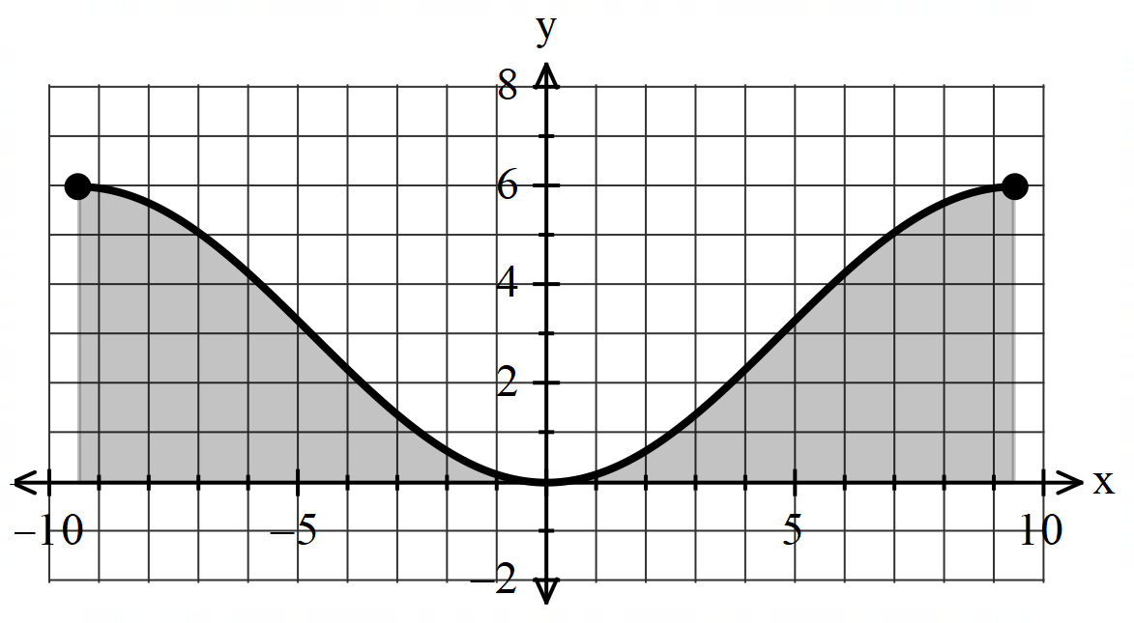

1. Determine the height of the sculpture (1 mark)

|  |
| --- |
| **Solution** |
|  |
| **Specific Behaviours** |
| * States the height with units |

1. Determine the volume of the material making the sculpture. (3 marks)

|  |
| --- |
| **Solution** |
| Volume = Area of the cross-section width  =  = m3 (or 169.65 m3 approximately) |
| **Specific Behaviours** |
| * Sets up the integral with correct boundary points * Determines the correct area * Determines volume (approx. or exact) no need for units |

1. Determine the coordinates of the steepest point(s) on the cross-section. Justify. (4 marks)

|  |
| --- |
| **Solution** |
|  |
| **Specific Behaviours** |
| P determines first and second derivatives  P equates second derivative to zero and solves for 2 values in domain  P gives coordinates for both points  P calculates gradient at both points (-1 and 1) to justify equally as steep (accept third derivative test with correct conclusion) |

Additional working space

Question number: _______

Additional working space

Question number: ________

Additional working space

Question number: ________